培育具有全球化视野、全融化思维、可持续发展能力的企业思想家
To Cultivate the Entrepreneurial Thinker with Global Perspective, Fusion Thinking and Sustainable Development Ability

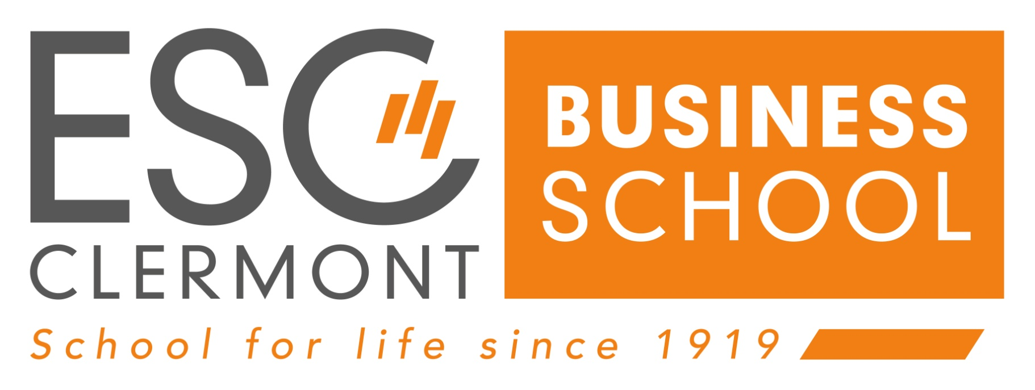
克莱蒙高等商学院（ESC Clermont）
Ecole Supérieure de Commerce de Clermont-Ferrand

工商管理博士学位 DBA
Doctorate in Business Administration

ESC Clermont: “School for Life”
克莱蒙高等商学院的“终身教育”价值观

家庭精神
家庭是一个社会基准，帮助我们每个人成长，帮助我们在共同信任的氛围中塑造和发展我们的个性。我们从家庭精神中汲取能量。

合作精神
当成功是一种集体努力时，它会更美丽。在一个快速发展的世界里，知识和技能在为人们服务时是有意义的，协同并进更美好。

征服精神
正是通过渴求、热情和决心，才能体现出创造力，创意和创新从而将涌现出来。健康的竞争是激励和进步的源泉。

平衡和谐
个人的稳定是全球和谐社会的关键，在这个社会中，每个人都可以自由地给自己定位，工作时的快乐和幸福是最重要的。

ESC Clermont’s Values: “School for Life”

Family Spirit:

Family is a social benchmark that helps each and every one of us to grow, helping to shape and develop individual personalities throughout our lives in a climate of shared trust. We draw our energy from our family spirit.

A Spirit of Cooperation:

Success is more beautiful when it is a collective endeavour. In a fast-evolving world, where knowledge and skills have meaning when they serve people, we are better together.

A Spirit of Conquest:

It is through desire, enthusiasm and determination that creativity can be expressed to bring ideas and innovation to the fore. Healthy competition is stimulating and a source of progress.

Balance:

We believe that individual stability is the key to a global harmonious society, where every individual is free to position his or her cursors. Happiness and well-being at work are a priority.

目 录 Content
学院寄语Message from the Director 1
克莱蒙高商About ESC Clermont 2
权威认可Accreditation 5
项目培养Program Cultivation 9
项目优势Program Advantages 11
课程体系Curriculum System 12
师资智库Faculty Team 15
学术体系Academic System 19
申请指南Application Guidance 21
毕业考核Assessment and Graduation 23
全球之旅Global Visit 26
校友网络Alumni Network 27
可持续价值Sustainable Development 29
校友平台Alumni Platform 30
克莱蒙高商剪影 ESC Clermont Moment 33

学院寄语Message from the Director
Françoise ROUDIER, director of Group ESC Clermont

Groupe ESC Clermont holds AACSB accreditation and is a Business School renowned for its programmes, the number and quality of its international partners, its dual-competences and transdisciplinary background and double-degrees, on top of its traditional fields of excellence.Testimonials from businesses, recruiters and the educational sector are recognition of our reliability, our high level of teaching and training methods and student support. The success of our 12,000 graduates attests that Groupe ESC Clermont can aptly be described as ”generating value”.
Our mission is to train managers and entrepreneurs possessing a sound knowledge in management, but also capable of understanding the challenges and the complexity of the economic and business world where creativity and innovation are an essential foundation for successful decision-making, actions and behaviour. Consequently, the guidelines for our programmes are to develop capacities for innovation, provide each student with a sound entrepreneurial background and accompany our students, future value providers, at an economic and societal level.
The intramural Square Lab Incubator supports the goals of this educational programme, and for our entrepreneurial students it has a genuine leverage effect on the management and the success of their projects.
Benefiting from a teaching faculty that is faithful and committed to the success of its students, Groupe ESC Clermont thus accompanies students, senior executives, engineers and responsible managers through high-quality degree programmes.
Groupe ESC Clermont continues to be one of France’s leading Business Schools, supported by companies and a strong, collaborative network of 12,000 graduates.

学院寄语

克莱蒙高等商学院集团(Groupe ESC Clermont)拥有AACSB认证，是一所以其课程、国际合作伙伴的数量和质量、复合型能力、跨学科背景和双学位而闻名的商学院。
来自企业、招聘人员和教育部门的评价是对我们的可靠性、我们高水平的教学和培训方法以及学生支持的认可。我们1.2万名毕业生的成功，恰好说明克莱蒙高等商学院集团(Groupe ESC Clermont)可以创造价值。
（克莱蒙高等商学院 主任 Françoise ROUDIER）
我们的使命是培养具备良好管理知识的经理人和企业家，同时具备理解经济和商业世界的挑战和复杂性的能力，其中创造力和创新是成功决策、行动和行为的重要基础。
因此，我们项目的指导方针是提高创新能力，为每个学生提供良好的创业背景，并在经济和社会层面陪伴我们的学生——未来的价值提供者。
校内实验室孵化器支持这个教育项目的目标，对我们的创业学生来说，它对管理和项目的成功具有真正的杠杆作用。
得益于教师队伍的忠诚和致力于学生的成功，因此Groupe ESC Clermont凭借高质量的学位课程陪伴着学生、高管、工程师和负责任的管理者。
克莱蒙高等商学院集团(Groupe ESC Clermont)一直是法国领先的商学院之一，拥有众多企业和强大的合作网络，拥有1.2万名毕业生。

学院介绍 ESC Clermont Introduction

克莱蒙高商About ESC Clermont
Groupe ESC Clermont是一所声誉卓著的法国商学院。ESC Clermont （法语全称：Ecole supérieure de commerce de Clermont-Ferrand），即克莱蒙费朗高等商学院，简称“克莱蒙高商”。它成立于1919年，由法国商务部、克莱蒙费朗市、康塞尔总理事会、商会和一些伙伴公司的支持而成立。从那时起，来自各行各业的12000多名男女学员从特鲁登校区学习毕业。
Groupe ESC Clermont is a well-established French Business School. ESC Clermont is the short name of Ecole supérieure de commerce de Clermont-Ferrand. It was founded in 1919, under the patronage of the Ministry of Commerce, the City of Clermont-Ferrand, the Conseil Général du Puy-de-Dôme (General Council), the Chamber of Commerce and several partner companies. Since then, more than 12,000 men and women from all walks of life have walked the grounds of the Trudaine campus.

凭借坚定的全球视野，克莱蒙高等商学院集团与地方、国家和国际经济利益相关者建立了密切的关系。它与50多个国家约100所高等教育机构建立了伙伴关系，并拥有一支日益充实的师资队伍，由高质量的教授和研究人员组成，他们坚定地致力于商学院的座右铭“终身学院”。
With a resolutely glocal outlook, Group ESC Clermont has strong relationships with local, national and international economic stakeholders. It partnerships with some 100 Higher Education Institutions in more than 50 countries and has an ever increasingly enriched faculty composed of quality professors and researchers who are strongly committed to the Business School’s motto ”School for Life”.

克莱蒙高商是一所以学员为中心的商学院，以人为本，以双重能力、平等机会和多元化为全球战略。它是高等教育部为促进青年人(无论其社会经济背景和教育质量如何)获得教育机会而设立的Les cordez de la Reussite宪章的签署国和该组织的主要成员。
Groupe ESC Clermont is a learner-centric Business School organised on a human scale and promotes a global strategy with dual-competences and equal opportunities and diversity. It is a signatory of the charter of ’Les Cordées de la Réussite’ (a scheme set up by the Ministry of Higher Education to promote access for young people, regardless of their socio-economic background, and quality in education) and a leading member of the organisation.

随着学校庆祝100周年的展望,克莱蒙高等商学院坚定地转向各种现代教育学,数字世界和创业精神,旨在成为一个为来自不同的视野、网络和环境的所有利益相关者提供学习、实验和创新的场所。2014年创建的商学院校内的孵化器(SquareLab) 和2015年落成的Quartier des Labs土壤实验室（整合资源鼓励实施项目制，并最终提高毕业生的就业能力），这两项举措是推动克莱蒙高等商学院项目和未来战略的强有力的证据。
As the School looks to celebrate it’s 100th Anniversary, Groupe ESC Clermont is resolutely turned towards all kinds of modern pedagogy, the digital world and entrepreneurship and aims to be a place of learning and of experimentation and innovation for all its stakeholders from various horizons, networks and environments. The creation of the Business School’s intramural incubator in 2014 (SquareLab) and the inauguration in 2015 of its ‘Quartier des Labs’ (a combination of resources encouraging the implementation of projects and ultimately the employ ability of graduates), is powerful evidence of the dynamism driving Groupe ESC Clermont’s projects and strategy for the future.

- 学校重要数字 Key Figures of ESC Clermont
12,000 名毕业生遍布全球130个国家
约1200名在校学生
在校国际学生超过300人，来自 50多个不同国家
学生协会9个
全职教员43人
兼职教员200 +
高等教育伙伴100个••
企业合作伙伴200家

12,000 Graduates in 130 Countries
Approx. 1,200 Students
Over 300 International Students On the Campus from More than 50 Different Countries
9 Students Associations
43 Full-Time Faculty Members
200 + Adjunct Faculty Members
100 Higher Education Partners
200 Corporate Partners

权威认可Accreditation
- 国家教育部认可 Recognized by MOE
ESC Clermont是一所公立学校，成立于1919年。当法国教育部认为一些私立教育机构有助于公共教育服务时，它会给予认可。1919年成立时为领事机构的Groupe ESC Clermont立即获得了无限期的国家承认。这一认可证明了克莱蒙高等商学院作为高等教育机构的合法性和可靠性。
作为一所历史悠久，教育质量高，且获得AACSB认证的商学院，ESC Clermont 克莱蒙高等商学院也得到了中国教育部的官方认可。中法就此展开良好的国际交流及教育项目合作。共同为学生提供更多更好的学习途径和学习资源。
ESC Clermont now is a public school founded in 1919. The French Ministry of Education recognises some private institutions when it considers that they assist the public education service. Groupe ESC Clermont, a consular establishment when it was founded in 1919, immediately obtained state recognition for an indefinite period. This recognition certifies the legitimacy and the reliability of our Business School as a Higher Education establishment.
As an AACSB-accredited business school with a long history and high quality of education, ESC Clermont is also officially recognized by the Chinese Ministry of Education. China and France have conducted sound international exchanges and cooperation in educational projects to provide students with more and better learning paths and resources.
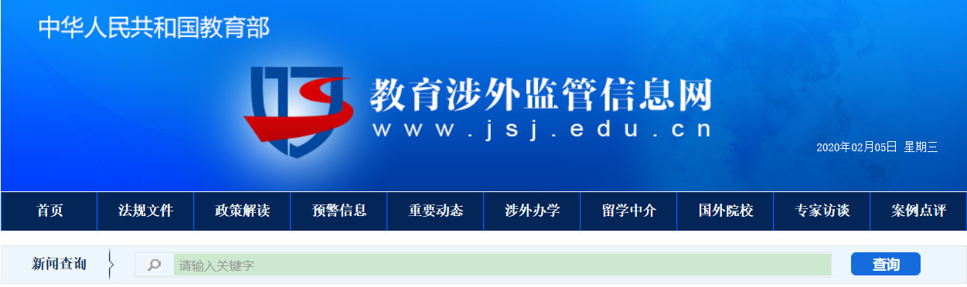
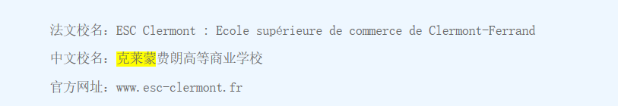
（信息来源 Source：http://www.jsj.edu.cn/n1/12033.shtml）
克莱蒙高等商学院为中国教育部认可并推荐的法国商学院
ESC Clermont Business School is accredited and recommended by the Chinese Ministry of Education(MOE)
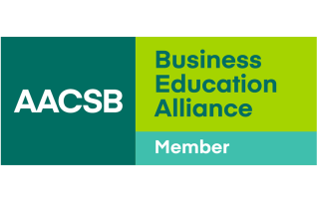
- 获得AACSB认证 Accredited by AACSB
Groupe ESC Clermont自成立以来一直是国家认可的学校，这证明了它作为一个可靠的高等教育机构的合法性和稳固的声誉。自1985年以来，克莱蒙高等商学院一直是高等商学院会议(Conference des Grandes Ecoles)的成员;自1986年以来，一直是高等商学院管理学院(Chapitre des Grandes Ecoles de Management)的成员;并于2005年获得AACSB认证，获得国际认可。
ESC Clermont是拥有AACSB认证（国际高等商学院协会）的为数不多的商学院之一（全球不到5％的学校获得此认证）。AACSB国际认证提供对学校组织过程质量的独立评估 ，确保所提供课程的内容和质量符合既定的国际标准。
Groupe ESC Clermont has been a state-recognised School ever since its inception, which certifies its legitimacy and solid reputation as a reliable Higher Education Institution. ESC Clermont has been a member of the ‘Conférence des Grandes Ecoles’ since 1985, a member of the ‘Chapitre des Grandes Ecoles de Management’ since 1986, and has obtained international recognition with the awarding of the AACSB accreditation since 2005.
ESC Clermont is one of the few business schools to have an AACSB accreditation (less than 5 % of schools accredited worldwide). AACSB (The Association to Advance Collegiate Schools of Business) provides an independent assessment of the quality of the school's organizational processes to ensure that the content and quality of the courses offered meet established international standards.

- 权威联盟成员 Authorized Alliance Members
ESC Clermont是多个国际知名联盟和机构的成员，例如：
- Groupe ESC Clermont是Grandes Ecoles精英大学校（非营利性工程学校、管理学校和提供其他专业的高等教育机构的协会）的会员。

- AGERA（The Alliance des Grandes Écoles Rhône-Alpes Auvergne ）的成员，AGERA是法国最重要的商学院联盟之一。

- EMBS联盟的创始成员之一，EMBS（欧洲管理和商业科学网络）目前有16家欧洲高等教育机构(大学和商学院)。Groupe ESC Clermont在1998年至2014年期间主持该联盟的工作，自2014年9月起负责其法律顾问和财务业务。

- Groupe ESC Clermont是NIBES网络的活跃成员。NIBES（国际商学院和经济学院网络）拥有20所商学院和经济学院，分布在5大洲，其中包括2013年之前一直担任法律顾问的Groupe ESC Clermont，自1996年以来让Avec 5000名校友参与学生流动项目。

- Groupe ESC Clermont是EFMD成员。EFMD（欧洲管理发展基金会）是全球最重要的商学院网络之一，作为该网络的一部分，为师生交流、知识共享和合作带来了许多机会。

ESC Clermont is a member of many internationally renowned alliances and institutions such as:
- Groupe ESC Clermont is a membre de la Conférence des Grandes Ecoles (non-profit association of engineering schools, management schools and higher education institutions offering other specialities).

- Groupe ESC Clermont is a member of the AGERA（The Alliance des Grandes Écoles Rhône-Alpes Auvergne ）. The AGERA is one of the most important alliances of business schools in France.

- Groupe ESC Clermont is a founding member of the EMBS consortium.The EMBS Net consortium (European Management & Business Sciences Network) today numbers 16 European higher education establishments (Universities and Business Schools). Groupe ESC Clermont presided this network between 1998 and 2014 and since September 2014 it is responsible for its legal counsel and treasury operations.

- Groupe ESC Clermont is an active member of the NIBES network.The NIBES (Network of International Business and Economic Schools) numbers 20 Business and Economics Schools spanning over 5 continents, including Groupe ESC Clermont which was responsible for its legal counsel until 2013 and involves avec 5 000 Alumni in student mobility programmes since 1996.

- Groupe ESC Clermont is member of EFMD. EFMD(European Fund for Management Development) is one of the key business schools networks in the world and being part of the network brings many opportunities for faculty and student exchanges, knowledge sharing and collaboration.

- 权威排名 Authorized Ranking
随着学校项目组合的发展，特别是与全球化商业世界不断变化的需求、创新和教学相适应的新课程的推出，克莱蒙高等商学院提供了全面的课程。创立于2007年的国际管理学学士或管理学硕士课程，在法国《费加罗报》(Le Figaro)排名和国际排名中都占据显著位置，而且经常上榜（英国《金融时报》榜单中前100名）。
法国排名
- 2018年法国最好的商学院第22名——《法国费加罗报(Le Figaro）》排行榜。 该报纸创立于1826年，是法国第二大综合性日报。
- 最受研究生推崇的商学院第9名——法国《学生报(l’Etudiant) 》排行榜。

国际排名
- 2018年全球最佳管理硕士100强——英国《金融时报》排行榜

With the development of its Programmes portfolio, and in particular the introduction of new programmes that are aligned with the changing needs of the globalized business world, innovation and pedagogy, Groupe ESC Clermont has a comprehensive course offering. The Bachelor in International Management, created in 2007, or the Master in Management programme, both figure prominently and regularly in national rankings (Le Figaro) and international rankings (Top 100 of the Financial Times).

National rankings in France
- 22nd best French Business School – Le Figaro.fr 2018
Founded in 1826, Le Figaro is the second largest comprehensive daily newspaper in France.
- 9th most recommended business school by graduates – l’Etudiant

International rankings
Top 100 best Business School in the world for a Master in Management in 2018 – Financial Times Ranking

项目介绍 Clermont-DBA Program

项目培养Program Cultivation
- 培养理念 Cultivation Concept
ESC-DBA项目，秉承克莱蒙高等商学院百年历史使命和价值观，致力于培育学员成为企业及行业中敏捷和积极主动的管理者、企业家和引领者。
通过项目的学习，提升学员具有全球化水平的商业视野和理解能力，并扎根于专业领域的管理理论和商业实践，增强管理的高度实践性。
The Clermont-DBA program is committed to the centennial mission and values of Group ESC Clermont dedicated to educate and train our students to be agile and proactive managers, entrepreneurs and leaders in their enterprises and industries.
Through the study of the program, students will have a global business vision and understanding ability, and be rooted in the management theory and business practice in the professional field to enhance the highly practical management.

- 培养对象 Target Students
Clermont-DBA项目主要针对具有丰富实践经验，并且已经掌握一定管理理论的企业高级管理者和企业家。且期望在以下三方面着重突破现状的学员：
- 期望进一步将自己的商业视野提升到全球化标准的新高度；
- 同时期望突破当前所处环境或所学及实践管理等方面的思维格局，想从不同角度或全球化环境资源及教育中吸收新思维，升级思维模式；
且期待在未来经营管理企业方面带领员工或行业同仁走向新高度，实现企业在不同时代能成功吸收新知识及迎接新挑战，实现企业长足稳定的可持续发展。

Clermont-DBA mainly aims at achieving senior managers and entrepreneurs who have rich practical experience and have mastered certain management theories,especially students who expect to focus on breaking the status quo in the following three aspects:

- Look forward to further raising one’s business vision to new global standards;
- Meanwhile hope to break through the current thinking pattern of environment or what learned and practical management, and to absorb new thinking and upgrade the thinking mode from different perspectives or the global environmental resources and education;

- Moreover look forward to leading employees or industry colleagues to a new height in the future enterprise management , and successfully absorbing new knowledge and meeting new challenges in different times to achieve long-term, stable and sustainable development of the enterprises.

- 培养方向 Cultivation Direction
Clermont-DBA 项目通过高级企业经营者必须具备的四个维度的能力，即全球化能力、可持续发展能力与学习能力、科学逻辑能力、以及理论应用能力的专业性培养，具体从以下几方面促进学员提升:
- 系统掌握工商管理基础知识
- 能够理解全球化环境下经济和商业世界的挑战与复杂性，探索及发展前沿管理理论
- 成为经济、社会和全社会的价值创造者

Clermont-DBA program aims to empower excellent leaders with four capabilities, namely, globalization capability , sustainable growth capability,scientific thinking and logic capability and application capability of management theory.Specifically promote students from the following aspects:
- Systematically endowed with knowledge of the fundamentals of Business Administration;
- capable of understanding the challenges and complexity of the economic and business world in a globalized environment; meanwhile explore and develop frontier management theory;
- creators of value from an economic, social and societal standpoint.

项目优势Program Advantages
Clermont-DBA项目将利用中法及全球化的学产研生态系统(项目/实验室/研究)，与我们的伙伴密切合作，与学员一起生产和发布知识，以及赋能学员公司和组织的发展，并助推区域经济发展和吸引力提升。秉承克莱蒙高等商学院的百年发展史，Clermont-DBA项目具备5大显著优势：
Clermont-DBA Program will leverage the sino-french and global research ecosystem (Programmes /Labs /Research), be in close cooperation with our public and private partners,produce and publish knowledge together with students, and improve development in companies and organizations as well as support the regional economic development and attractiveness.Following the centennial history of Group ESC Clermont, the Clermont-DBA Program has five dominant advantages:
- 学术成就卓越
克莱蒙高商是法国最古老的商学院之一。自1919年成立以来，商学院凭借其由经验丰富的教授和专业人士组成的师资队伍，成功地为商界领袖提供了毕业机会。因而Clermont-DBA项目的学员将会得到高质量的教学及学术服务。
Academic excellence
Groupe ESC Clermont is one of the oldest business schools in France. Since its establishment in 1919, the School has continually been successful in graduating business leaders through its faculty of experienced professors and professionals.Therefore, students of Clermont-DBA Program will be provided with high quality teaching and academic services.

- 强有力的伙伴关系
与100多所国际顶尖商学院和大学建立了合作关系。学校还与许多国内中小企业和国际企业建立了密切的联系。本科和研究生课程部分或全部用英语授课。Clermont-DBA项目将采用全英文授课的方式，学员获得到良好的国际化思维及认知提升的同时，国际化语言能力也将得到完善。这将更好地促进学员的事业全球化发展。
Strong partnerships
Groupe ESC Clermont has partnerships with over 100 leading international business schools and universities. The school also has close ties with many national SMEs and international corporations. Clermont-DBA Program will be taught in English, so that students can improve their international thinking and cognition, and meanwhile their international language ability will be improved,which will better promote the globalization of students' career development.
- 商学全球前5%资质
在AACSB认证的商学院中，克莱蒙高等商学院名列全球前5%——AACSB认证是全球商学院最重要的认证之一。根据英国《金融时报》和费加罗(Figaro) /“Etudiants”排行榜，它也是法国和欧洲最好的商学院之一。
World’s top 5% of business schools
Groupe ESC Clermont is counted amongst the world’s top 5% of business schools that is AACSB-accredited ---one of the most important accreditations for Business Schools worldwide. It is also one of the best business schools in France and Europe according to the Financial times and Figaro/”Etudiants” rankings.

- 高品质的学生生活
学校位于法国克莱蒙特-费朗，为法国的心脏地带，被认为是法国最好的学生城市之一，共有42000名学生。这座城市也是最适宜的留学地点之一。Clermont-DBA项目的学员将享有国际游学及参访学习的良好机会，融入母校，深度体验其优良学风。
Top quality of student life
Clermont-Ferrand, located in the heart of France, is recognized as one of the best student cities in the country with a total of 42,000 students. The city is also among the most suitable places to study.
Students of Clermont-DBA Program will enjoy good opportunities for international study Tours and visits to study in the Alma mater.

- GDA校友平台领航
协进教育集团作为国内高等商学教育领域的领航者，拥有独一无二的教育全球化能力和中外双向校友资源平台，这与克莱蒙高商的高度国际化伙伴关系及企业网络不谋而合。双方共同携手为学员提供优质的学习项目和教育服务。
Leading GDA alumni platform
As a leader in the field of higher business school education in China, CPMC (Co-progess Education Group) has the unique ability of education globalization and a two-way alumni resource platform, which coincides with the Group ESC Clermont of highly international partnerships and enterprise networks. Both parties will work together to provide students with high-quality learning programs and education services.

课程体系Curriculum System
- 学习概况 Study Overview
- 学制周期：学制三年（不脱产在职学习）
- 课程安排：课程分为两个阶段，课程将贯穿博士学习的第一年和第二年。学员将在博士学习的第一年下半年开始论文的准备工作，即确定论文研究方向和主题，并提交博士论文开题报告；同时紧随项目学术中心的安排，在学制第三年，完成论文写作及答辩，方可顺利毕业并获得博士学位。为了帮助博士完成最终的论文及答辩，项目学术中心将根据学员的研究课题，安排相对应的论文指导教授。
- 授课语言：中文授课，英文授课将配备专业口译
- 授课方式：采用小班精英授课形式，期间将安排主题研讨会，论坛，讲座等活动
- 授课地点：国内：上海及其他城市的国内移动课堂；国外：ESC克莱蒙高商
- 授课时间：国内课程平均每月周末集中授课一次，每次2-3天

- Program Duration: The program duration is 3-year（on-job learning）
- Course Arrangement: It is divided into two phases. In the first and second years, students will study core courses. Among the first one and half years, students will begin to prepare on thesis writing ,that is to determine the research direction and topic, and submit the thesis proposal report; and then according to the arrangement of the program academic center, students should finish the thesis writing and defense in the third year to successfully graduate and obtain a doctor's degree.In order to help the doctoral candidate complete the final thesis and defense, the program academic center will arrange corresponding thesis supervisors according to the students' research topics.
- Teaching Mode: Small VIP class, during which themed seminars, forums, lectures and other activities will be arranged
- Teaching Language: Chinese, English with on-site Chinese professional interpreter
- Teaching Location: Domestic place: Shanghai or other cities in China; Oversea place: ESC Clermont in France
During the study, there will be opportunities for students to attend industry seminars, lectures of famous scholars, trips to French Alma mater and international seminars.
- Teaching Time: Intensive classes will be taught on weekends with 2-3 days per month (on Friday, Saturday, Sunday)

- 课程构成Course Structure
Clermont-DBA项目以成就具有全球视野、全融思维、以及可持续发展能力的企业思想家为终极教育目标，通过为学员提供认知类，学术研究类，管理专业类等系列课程，结合企业案例及最新发展趋势进行深入剖析和探索，最终促使学员实现思维的突破和实践升级发展。
Clermont-DBA Program is to cultivate the entrepreneurial thinker with global perspective, fusion thinking and sustainable development ability.The program willultimately promote students’ thoughts breakthrough and upgrade development practice through providing students with courses of cognition, academic research , management and others , combining with the enterprise cases and the latest development trend of in-depth analysis and exploration.
序列 | 培养模块 | 课程名称 | 授课导师
1 |  | 营销学主要理论（I）（Ⅱ） | 中方
2 |  | 组织与战略主要理论（I）（Ⅱ） | 中方
3 |  | 人力资源主要理论（I）（Ⅱ） | 中方
4 |  | 金融主要理论（I）（Ⅱ） | 中方
5 |  | 管理科学领域学术写作与发表 | 法方
6 |  | 专业知识教学 | 法方
7 |  | 职业与 DBA : 研究与管理实践的结合 | 中方
8 | 研究方法类课程 | 管理科学研究方法论，认识论，研究方法论 | 法方
9 |  | 定性方法论 | 法方
10 |  | 定量方法论 | 法方
11 | 论文指导及撰写 | 论文写作与答辩 | 法方
除了保证学员全面的知识输入，Clermont-DBA项目还将为学员提供知识理论和实践经验的输出平台，由学生主讲的微课堂，行业沙龙，思辨会，以及企业管理咨询服务。每位学员企都将发挥价值及享受到项目为其提供的持续增长和终身学习的服务。
In addition to ensuring students' comprehensive knowledge input, Clermont-DBA Program will also provide students with an outlet platform for knowledge theory and practical experience. Students can participate in small lectures hold by graduates, specialized salons, thoughts debates and enterprises management and consultation services.

师资智库Faculty Team
汇聚国内外著名教授，他们兼具丰富的实践经验，深厚的理论基础，高超的文化素养，授课师资平均至少有15年以上教学及企业管理相关实操经验，这样的师资阵容将为DBA学员提供最前沿的学术思想，最科学的理论支持，同时结合中国国情，以全球化视角为学员提供理论与实践之间科学转换的极致体验。
ESC Clermont Program has gathered famous professor both at home and abroad. They have abundant practical experience and profound theoretical foundation, the high level of literacy. Each professor of the faculty team has at least 15 years teaching and management experience in related field, so they can provide the DBA students with forefront academic thoughts, the most scientific theory support, combined with China's national conditions at the same time, in view of globalization provide students with the perfection of scientific transformation between theory and practice experience.

- 部分师资介绍 Part of the Faculty
外方教授
Marc Lecoutre 教授
Professor Marc Lecoutre
组织与管理学教授，克莱蒙ESC集团研究中心主任，CleRMa研究员，交互管理、人类潜能与创新的核心成员。
Professor of Organization and Management; Director of the Clermont ESC Group Research Center；Researcher of CleRMa, core member of Interaction Management, Human Potential and Innovation

研究方向：组织与管理、领导组织、文化组织的创新管理
Research Field: Organization and Management，leading organizations and innovative management in cultural organizations

Richard SOPARNOT 教授
Professor Richard SOPARNOT

理查德· 索帕诺是管理学博士、教授；克莱蒙高等商学院学术主任兼企业战略教授。他也是CleRMa成员。
Doctor of Management, Professor; Academic director of ESC Clermont Business School; Professor of Enterprise Strategy Management; Member of CleRMa

研究方向：战略和组织变革、企业创新以及知识在管理中的作用和相关性
Research Field: Strategy and Organization Change,Enterprise Innovation and Knowledge Utility and Relevance in Management

Yves Rannou 教授
Professor Yves Rannou

金融学教授，Clerma研究实验室常任成员
Professor of Finance, member of CleRMa
研究方向：金融工程，银行学，环境金融、金融市场的微观结构和行为金融学
Research Field: Financial Engineering ,Banking, Environmental Finance, Micro-structure of Financial markets, Behavior Finance

中方教授补充

丁宁 教授
Professor Ding Ning

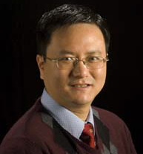

浙江大学商学院金融学副教授，财务管理与金融研究所副所长，Ph.D博士
Associate professor of Finance in Zhejiang University; Deputy director of Institute of Accounting Management and Finance, Ph.D

研究方向：共同基金和对冲基金，大规模金融数据库，金融模型，数量投资的研究和应用
Research Field: mutual funds and hedge funds, application of large-scale financial databases, financial models, and quantitative investment

沈丁立 教授
Professor Shen Dingli
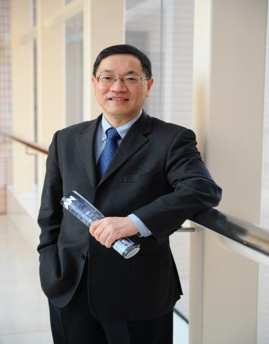

复旦大学教授、国际问题研究院前常务副院长、美国研究中心前主任，以及美国圣路易斯华盛顿大学荣誉访问教授

Professor of Fudan University; Former executive vice president of the Institute of International Studies, Former director of the Center for American Studies; Honorary visiting professor of Washington University in St. Louis
研究方向：中美安全关系、地区安全和国际战略、军控与防扩散、中美外交与防务政策
Research Field: Sino-US security relations, regional security and international strategy, arms control and non-proliferation, and Sino-US foreign and defence policy

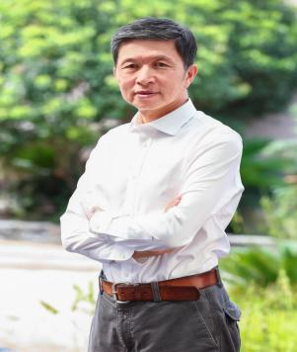
黄沛 教授
复旦大学、武汉大学、上海交通大学教授，博士生导师，
武大珞兰德科技公司 总经理
研究方向：市场营销学，管理学，竞争战略

Professor Huang Pei
Professor of Fudan University, Wuhan University,Shanghai Jiaotong University; doctoral supervisor
General Manger of Roland Technology Co., LTD
Research fields: Marketing,Management,Competitive Strategy

顾庆良 教授
东华大学管理学院教授、博士生导师、中国市场学会常务理事
研究方向：市场营销、产业经济管理、创新创业、企业家精神和企业家经济
Professor Gu Qingliang
Professor of School of Management,Donghua University;doctoral supervisor;Executive director of China Marketing Society
Research fields: Marketing, Industrial economic management, Innovation and entrepreneurship, Entrepreneurship and entrepreneurial economy

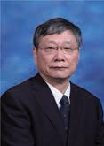
胡海鸥 教授
上海交通大学教授、 博士生导师
研究方向：信用经济学，货币理论与政策，中国宏观经济分析， 管理经济学

Professor Hu Haiou
Professor of Fudan University;doctoral supervisor
Research fields: Credit economics,Monetary theory and policy,
China macro-economic analysis,Managerial economics

学术体系Academic System
- 学术委员会Academic Committee
学习全程中，项目学术委员会将根据学员的研究课题，安排对应的中法导师及学术团队，开展论文工作坊对学员的论文写作进行跟踪指导，确保学员学习过程中的学术思维提升及能够顺利完成论文及答辩。
During the study, the academic committee of ESC Clermont program will arrange the corresponding Chinese and French supervisors and related team to hold thesis workshops for instructing the thesis writing according to students' research topics so as to ensure that they can improve their academic thinking and successfully complete the thesis and defense.

- “小黑屋”实训营 The “Black Room” Thesis Training Camp

#实训营宗旨# Purpose of the Training Camp

传承东方管理学精华，融合东西方管理学思想，缔造东方管理研究范式。通过研究中方及西方企业的商业模式和内在机制，以案例研究、定量研究、混合研究为基础，知行合一，推动中国企业管理理论的创新，构建适合中国的管理模式，同时促进企业家学术品牌化，成就企业思想家。
The purpose of the training camp is to inherit the essence of Eastern management, blend Eastern and Western management ideas, and create a paradigm for management research. By studying the business models and internal mechanisms of Chinese and Western companies, based on case studies, quantitative research and mixed research, we will promote the innovation of Eastern enterprise management theory, build a management model suitable for China, and at the same time, promote the academic branding of entrepreneurs and help them to become entrepreneurial thinkers.

#实训营目标# Objective of the Training Camp

学员在读期间，实训营将提供课程与论文之间的有效衔接与支撑，也为部分学员发表学术成果和推广案例研究提供专业指导。在学术探索过程中，我们更关注培养和塑造学员们对核心问题的聚焦和深度挖掘能力，对研究现状的思辨能力，以及对创新想法的抓取力和表述能力。

During the study, the training camp will provide effective connection and support between courses and thesis, and also provide professional guidance for some students to publish academic results and promote case studies. In the process of academic exploration, we pay more attention to cultivating and shaping students' ability to focus on and dig deep on core issues, the critical thinking ability of the status quo of research, as well as the ability to grasp and express innovative ideas.

#实训营服务# Services of the Training Camp

“小黑屋”实训营注重实操性与陪伴性，按模块拆解，将从下述八部分来辅导学员的论文写作，并最终提高学员进行学术研究的核心能力：

The "Black Room" Training Camp focuses on practicality and companionship. According to the module dismantling, the following eight parts will be used to guide the students' thesis writing, and finally improve students’ academic research ability:

- 绪论部分Introduction
- 文献综述Literature Review
- 研究假设（案例研究）Research Hypothesis (case study)
- 研究结论与展望Research Conclusions and Prospects
- 文献检索Literature Retrieval
- 模型构建Model Building
- 数据分析与结果Data Analysis and Results
- 论文特训 Thesis Special Training

（备注：小黑屋实训营不包含在Clermont-DBA项目必修课程中，学员可以根据自己的具体情况自由选择是否参加）

（Note: the Black Room Training Camp is not included in the cost of Clermont-DBA curriculum. Students can freely choose whether to participate in the special training if necessary）

申请指南Application Guidance
- 申请条件 Application Requirements
项目申请者必须具备以下资质：
- 由学术机构颁发的非企业管理或非财经类硕士学位，并有最少5年管理工作经验；
- 未具上述学历而有最少8年管理工作经验者，请向项目办公室提交附加材料特别申请入学。
Program applicants must have the following qualifications:
- A master's degree in non-business administration or non-finance from an academic institution with at least 5 years of management experience;
- Applicants who can’t meet the above qualifications should have at least 8 years of management experience, and should submit additional materials to the program office for special application.

- 申请材料Application Materials

基础材料 Basic Materials
- 报名申请表（中英文各一份）
- 个人简历（中英文各一份）
- 身份证和护照扫描件
- 最高学历学位证书扫描件及其翻译件
- 个人标准2寸白底证件照4张

附加材料
- 工作证明及相关研习经历
- 拟攻读博士学位的研究项目课题计划（1500-2000字，中英文各一份）
- 推荐信（2封）
- 奖励荣誉证书
* 提交申请时证件及证书只需要提供材料原件的扫描件（电子版），必要时协助出示相关证件原件。

Basic Materials
- Application forms (Chinese and English version)
- Resume (Chinese and English version)
- Scanned copy of passport and ID card
- Scanned copies and translations of the highest degree certificates
- 4 personal standard photos with 2-inch blue background

Additional Materials
- Work experiences certificate and related study experiences
- Research project plan to study for doctor's degree (1500-2000 words, Chinese and English version)
- 2 recommendation letters
- Certificates of honor
（*Note: When submitting the application, applicants only need to provide scanned copies of the original documents (electronic version), and assist in presenting the original documents if necessary.）

- 申请流程Application Process

- 递交报名表等上述申请相关材料
- 由校方录取委员会进行资格审核
- 申请者通过资质审核并参加面试（未通过者需要提交补充材料）
- 入学面试
- 通过面试后，将发放录取通知书
- 学员缴纳学费、学籍注册等费用
- 注册学籍成为Clermont-DBA正式学员

- Submit application materials mentioned above
- Review of the above materials by ESC Clermont admissions committee
- Applicants who pass the review , and then attend an interview(or else submit the additional materials)
- Attend an interview
- Pass the interview, and then issue the official admission letter of ESC Clermont
- Pay tuition ,register and other related fees
- Register and become an official student of Clermont-DBA

递交申请材料
申请者通过资质审核并参加面试（未通过者需提交补充材料）
校方录取委员会进行资格审核

通过
通过
缴纳费用
注册学籍
成为正式学员
入学面试
通过面试，发放录取通知书

Applicants who pass the review prepare to attend interview (or else submit the additional materials
Submit application materials
Review of the above materials by ESC admissions committee
Prelimary Review
pass
pass
Attend the interview
Pay tuition fees& Register
Be the official student
Issue the official admission letter

- 项目费用Tuition Fee
法国克莱蒙高等商学院DBA项目费用包含：入学面试费、学费、境外服务费；不包含项目国际游学期间往返法国的国际差旅费及赴法期间的食宿费。（若有疑问，请咨询DBA中国项目办公室）
The Clermont-DBA program fee includes: admission interview fee, tuition fee and overseas service fee; but the program study tour expenses of international travel expenses and the accommodation expenses in France are not included . (If in doubt, please consult Clermont-DBA Program China Office)

毕业考核Assessment and Graduation
- 学业要求 Study Requirement
学员需要满足以下要求，方可顺利毕业：
- 修完所有课程的学分；
- 按时完成每门课程作业，并取得10/20的成绩；
- 每门课程都将考核学员的出勤率，未满足要求的学员视为旷课，无成绩。
（*如无法按时出席课程，需提前向学习督导申请调课。）

To graduate successfully, students should meet the following requirements :
- Students are required to complete credits for all courses;
- Complete each course assignment on time with a score of 10/20;
- Each course will assess the attendance, students who do not meet the requirements recorded as absenteeism, and no course grades.
(* Students who cannot attend the course on time should apply to the learning supervisor for adjust the schedule in advance.)

- 论文要求 Thesis Requirement
- 学员需要完成一篇管理方向的博士论文，所选课题需要兼具学术和实践意义。
- 论文书面文件的语言必须是英文。
- 论文答辩时，由答辩委员会进行答辩评审，学员需使用英文进行口头展示并完成问答环节。

- Students are required to complete a doctoral thesis in management and its the topic should be both academic and practical.
- The written language of the thesis must be English.
- Thesis defense will be evaluated by defense committee . Students are required to give an oral presentation in English and complete the Q&A session.

- 学位授予Degree Award
学员完成所有课程，且通过博士论文答辩，在得到克莱蒙高等商学院学位评审委员会的认可后，学员将获得由克莱蒙高商颁发的工商管理博士学位证书，学位全球认可。
After completing all the courses, passing the doctoral thesis defense as well as being approved by Degree Review Committee of ESC Clermont, students will receive the Doctorate in Business Administration diploma，which is globally recognized.
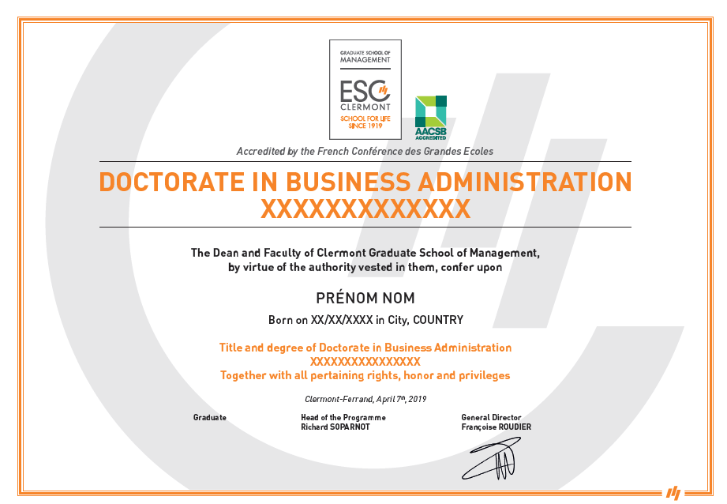
（证书样本仅供参考 Sample only for reference）

- 毕业盛典Graduation Ceremony

DBA学员将受邀参加克莱蒙高等商学院隆重举办的毕业典礼，这将是博士学习阶段的完美句点，也将是DBA学员荣耀加身的美好时刻。同时与校友的相聚将开启彼此新的未来连接。
DBA students will be invited to the grand graduation ceremony of ESC Clermont, which will be a perfect end to their doctoral studies and a glorious moment for DBA students. At the same time, the reunion with the alumni will open up new future connections with each other.

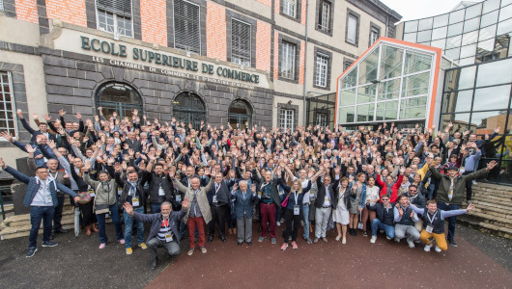

全球之旅Global Visit
全球视野作为全融教育DBA项目的特色，旨在帮助学员提升全球化接触能力，在全球游学过程中，通过跨文化交流与学习开拓新思维，此过程中收获的全球化资源和信息与本土实践经验结合，实现真正意义上的“Glocal”（即Global+Local）融合。校方鼓励学员积极参与此类活动。访学内容丰富充实，除了安排课程和参访，同时还将结合参访地当期的学术活动，为学员提供与参访地企业家沟通交流的机会。
（*具体游学安排请以ESC-DBA项目办通知为准）

Global vision, as a feature of the DBA program of fusion education, aims to help students improve their global contact ability. In the process of global study tour, students can explore new thinking through cross-cultural communication and learning, and combine the global resources and information gained in this process with local practical experience, so as to actually realize the integration of "Glocal" (i.e., Global+Local) . Students are encouraged to take an active part in such activities. The content of the visiting study is rich and substantial. In addition to arranging courses and visiting, it will also combine with the current academic activities of the visiting place to provide students with opportunities to communicate with entrepreneurs of the local place.
(*The specific arrangement is subject to the formal notice of the ESC Clermont Program office).

校友网络Alumni Network
克莱蒙高等商学院，拥有12000+位毕业校友。由于学校百年的商学历史影响力巨大，因此其人才多集中于市场营销、工商管理、金融、财务会计、国际商务、经济学、项目管理、人力资源管理、营销管理及国际研究等商科学习及工作领域。
ESC Clermont Business School has over 12,000 alumni. Due to the great influence of the school's century-old business education history, its talents are mainly concentrated in the business study and work fields of marketing, business administration, finance, accounting, international business, economics, project management, human resource management, marketing management and international studies.

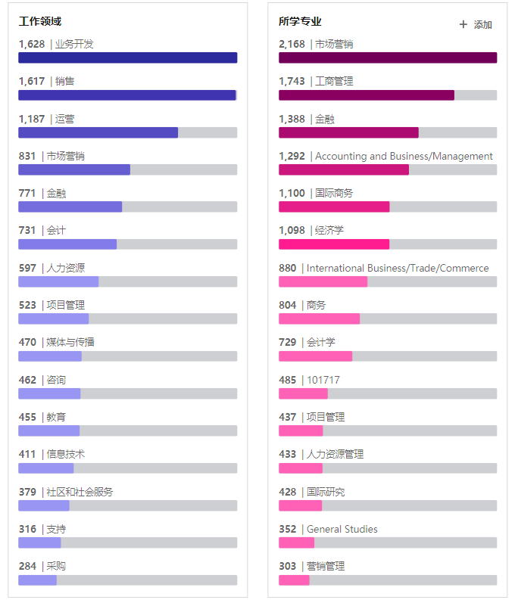

克莱蒙高等商学院具有高度的国际性及广泛的合作伙伴，毕业生就业面广。校友从业及定居以欧洲国家法国、德国、瑞士、英国、西班牙为主，同时辐射美洲美国及亚洲中国等国家及中心地区。大部分校友在银行等金融机构、会计事务所等知名企业及机构工作，如法国巴黎银行、法国兴业银行、法雷奥、安永、米其林以及克莱蒙特费朗集团Group ESC Clermont等。
ESC Clermont Business School is highly internationalized and has wide range of partners, so graduates has a wide range of employment. The alumni are mainly from France, Germany, Switzerland, Britain and Spain in Europe, and also from America, China and other countries in Asia. Most of the alumni work in banking and other financial institutions, accounting firms and other well-known companies and institutions, such as BNP Paribas, Societe Generale, Valeo, Ernst & Young, Michelin and Group ESC Clermont-ferrand.

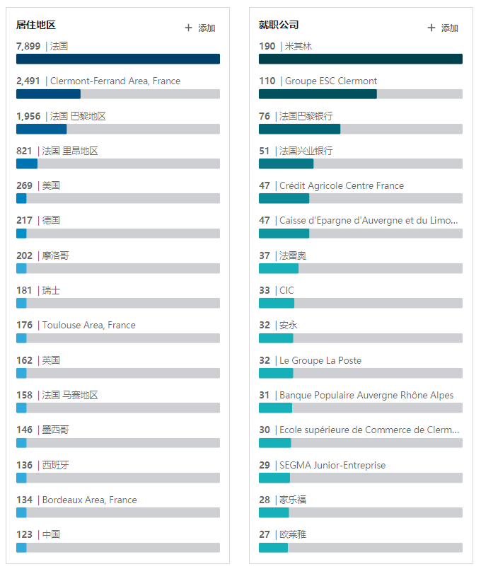

可持续价值Sustainable Development
- 终身学习理念Lifelong Learning Concept
Clermont-DBA项目鼓励学员持续不断地学习新知识新理论，同时也积极为所有博士校友提供终身教育的机会，旨在为校友提供可分享知识和经验、扩大潜在商机、增进彼此友谊的学产研融多维度发展平台。
Clermont-DBA program encourages students to continuously learn new knowledge and theories, and also actively provides lifelong education opportunities for all doctoral alumni. It aims to provide a multiple dimensional platform of “Education-Industry-Research” for alumni to share knowledge and experience, expand potential business opportunities and enhance mutual friendship.

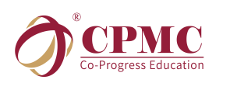
- 精彩的GDA名师讲堂 ✓Brilliant GDA Talk
名家讲堂嘉宾主要是来自各行业兼具实战经验、学术高度的业界精英和资深学者，是校友们学习交流国内外最新研究成果、管理实践和政策动态的良好平台。
Distinguished speakers of GDA Talk are mainly elites and senior scholars from various industries with practical experience and high academic level. GDA Talk provides a good platform for alumni to learn and exchange the latest research results, management practices and policy trends at home and abroad.

- 丰富的精品课程选修 Abundant Excellent Elective Courses
每年定期邀请来自不同行业的优秀博士学员，重返课程，角色从原来吸收知识的学员转换为输出知识的授课嘉宾，课程涵盖金融，医学，文化，教育，智能制造，数字经济，体育等领域，师资精良，经验丰富，实用性强。
Every year, excellent doctoral students from different industries are regularly invited to return to the class, and their roles are changed from students who have absorbed knowledge to lecturers who will output knowledge. The courses cover finance, medicine, culture, education, intelligent manufacturing, digital economy, sports and other fields. Teachers are excellent and with rich experience and courses is with strong practicability.

- 专业的商业咨询服务 Professional Business Consulting Services
学员还将享受来自GDA（全球工商管理博士联合会）提供的商业运作及上市等咨询服务，持续赋能在读及毕业校友的企业未来发展。
Students will enjoy consulting services such as business operations and listings provided by GDA, and continue to empower the future development of current and graduated alumni.

- 多样的俱乐部交流活动 Various Club Exchange Activities
本着丰富业余生活、拓宽视野、增加交流的目的，学员还将拥有参加各类俱乐部（如高尔夫俱乐部，羽毛球俱乐部，足球俱乐部，登山俱乐部等）的活动，借此加强校友之间，校友与项目之间的联系。
With the purpose of enriching amateur life, broadening horizons, and increasing communication, students will have the opportunity to participate in various clubs (such as golf club, badminton club, football club, mountaineering club, etc.) to strengthen the connection between alumni and projects.

校友平台Alumni Platform
- GDA（全球工商管理博士联合会）
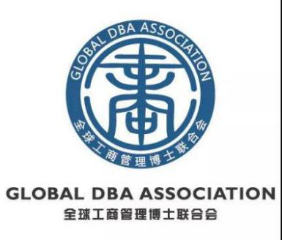
全球工商管理博士联合会 GLOBAL DBA ASSOCIATION（简称GDA），Clermont-DBA项目为该委员会主要成员之一。联合会致力于联合全球多所高校，建立与加强成员之间联系，增进校友之间友谊；促进不同国家不同地域的DBA同学之间的学术交流；服务并支持DBA同学的事业发展；推动DBA教学及其他学术标准制定，推广DBA研究成果；凝聚DBA同学践行世界终身教育事业，共同建设全球学产研生态圈。

GDA(GLOBAL DBA ASSOCIATION)
Clermont-DBA Program alumni can apply to join GDA to pursue higher life goals. GDA is committed to combining a number of global universities, establishing and strengthening the links among members, promoting friendship between alumni; promoting the academic communication between DBA students from different countries and different regions; serving and supporting DBA students' career development; promoting the DBA instruction and the formulation of other academic standards and promoting the DBA research results; gathering DBA students and practicing the world of lifelong education, and thus jointly building the ecosystem of the global Education-Industry-Research.

- EMSS（管理思想践行学会）

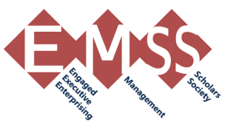

管理思想践行学会(Engaged Management Scholarship Society)， 是注册于英国伦敦的非盈利学术组织，旨在搭建研究平台，凝聚学术力量， 推动交流合作，传播研究成果，从而更深入地在文化多样性的背景下，研究中欧企业成功的商业模型和内在机制，并推动中国企业管理理论创新，总结中国管理特色，构建中国管理模式，传播中国文化管理理念，扩大中国企业影响力。该学会的主要成员是以工商管理博士学员为主体的企业家以及从事管理学研究、注重理论与实践相结合的学者。

EMSS(Engaged Management Scholarship Society)

EMSS is a non-profit academic organization registered in London, UK. EMSS aims to build a research platform, gather academic strength, promote exchanges and cooperation, disseminate research results and thus more deeply to study the successful business model and internal mechanism of Sino-European enterprises in the context of cultural diversity, so as to promote the innovation of Chinese enterprise management theory, sum up the characteristics of China's management, build China's management model, disseminate Chinese cultural management philosophy, and expand the influence of Chinese enterprises. The major members of the group are entrepreneurs who are mainly DBA students and scholars who are engaged in management research, focusing on the combination of theory and practice.

- CMA（世界终身教育委员会）
世界终身教育委员会（CMA，全称Comité Mondial pour les Apprentissages tout au long de la vie）, 是法国一个非营利性协会，由联合国教科文组织大会主席和包括中国人在内的国际小组共同创建。
CMA是联合国教科文组织的正式合作伙伴，其组织目标是与个人、组织以及公共部门共同促进终身学习。
CMA的使命是作为各方沟通的桥梁支持终生学习委员会开展工作，创建有利于终生学习委员会创新和改进的挑战性环境。这将有助于人们提高自身能力和所处社会整体能力。总体目标是促进人的能力发展，走向更快乐的社会生活。

CMA(Comité Mondial pour les Apprentissages tout au long de la vie)

The World Committee for Lifelong Education(CMA is short for Comité Mondial pour les Apprentissages tout au long de la vie ) is a non-profit association in France, co-founded by the President of the UNESCO General Assembly and an international group which includes Chinese members.
CMA is a formal partner of the United Nations Educational, Scientific and Cultural Organization (UNESCO). Its organizational goals are to promote lifelong learning with individuals and organizations, including the public sector. After joining the program, students will enjoy the guidance through their lifelong learning and will have the opportunities to find business partners, and to participate in international projects.
The mission of CMA is to serve as a bridge for communications between different parties to support the work of CMA and create a challenging environment that will benefit CMA's innovation and improvement. This will help people improve their abilities and the overall capabilities of the society. The overall goal is to promote the development of human capabilities and move towards a happier social life.

克莱蒙高商剪影 ESC Clermont Moment
